**ORCA Tool Preliminary Scope**

**Description:** The ORCA (Outbreak Response and Costing Analysis) app/website would be a convenient and efficient tool used to track costs associated with a public health outbreak response. The tool would allow outbreak investigators to track time, tasks, roles, and costs accrued for multiple outbreak responses simultaneously. It would allow for real-time tracking (daily or weekly) as well as retrospective tracking (i.e., at the end of an outbreak). Investigators using the tool should be able to easily view and edit their data throughout an outbreak. The tool will also need backend data persistence where select users can export results in a format that can be easily merged with results from other platforms (e.g., REDCap). Ideally, the tool would also allow admin users to add new outbreaks and customize tasks/roles as needed.

**App Features:**

* Outbreak-specific modules
  + This will allow a user to track and report time for multiple outbreak responses simultaneously.
* Controlled access to outbreak modules with sharing capacity
  + Users will only be able to track and report time for an outbreak if the module is shared with them. This will limit access to those directly involved. Those with access to an outbreak module should be able to share access with others.
* Time-tracking capabilities
  + A convenient and easy way to share the time spent responding to an outbreak by day, week, or over an entire outbreak response. Time tracking should be broken down into the tasks and roles they completed.
* Notifications to remind individuals to track time
  + Ability to set how often individuals should be reminded through a push notification (daily, weekly)
* Cost-tracking capabilities
  + Able to collect information on costs associated with an outbreak response. Costs should be collected along with time if tracking the outbreak in real-time.
* Ability to track and report time and costs as an individual, a team, or to report on behalf of someone else
  + Users should be able to report time/costs for themselves or others as needed.
* Reports on time, tasks, roles, and costs easily viewable
  + Should have graphs or some other visual that show these four metrics in real time
* Integration between the tool and an online survey?

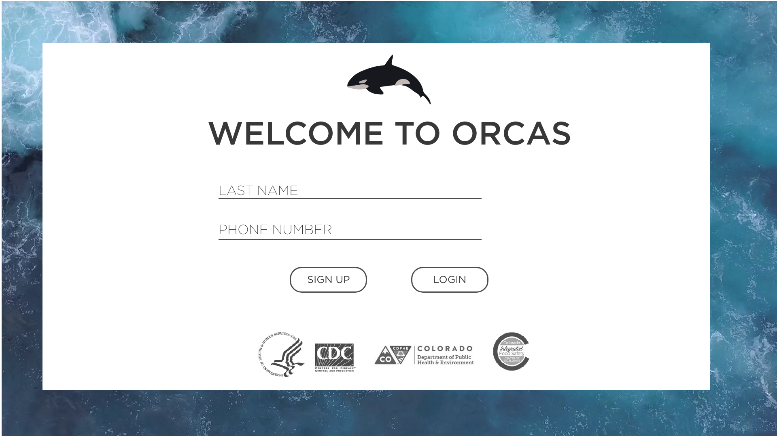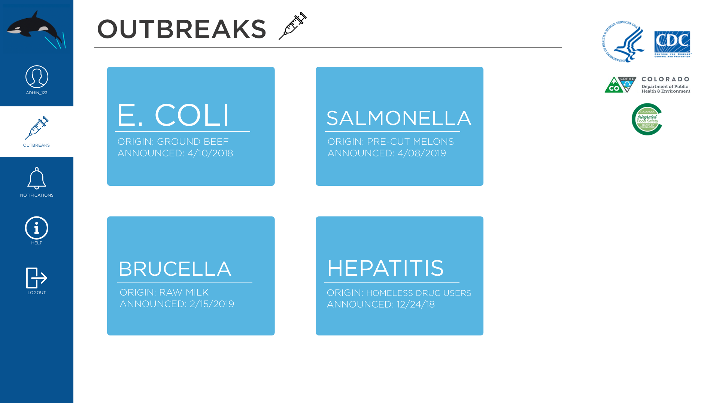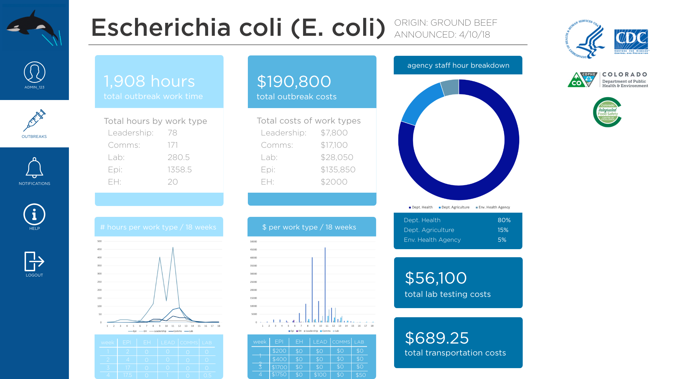

**App specifics:**

1. Agency/Job title
2. Roles to be tracked:
   * Epidemiology
   * Communicable Disease Investigator
   * Public Health Nurse
   * Student Interviewer
   * Environmental Health
   * Agency Leadership/Investigation Team Management
   * Laboratory
   * Administrative
   * Legal
   * Communications
   * *Other*
3. Tasks to be tracked:
   * Routine Case Interviews
   * Supplemental Case Interviews
   * Data Entry
   * Data Management
   * Data Analysis
   * Communication with the Investigation Team (email, meetings, etc.)
   * Communication with the Public
   * Coordinating Specimen Collection
   * Conducting Environmental Assessments
   * Interviewing Food Handlers
   * Collecting Samples Related to Environmental Health
   * Food or Attendance Record Collection
   * Attending or Supervising Investigation-Specific Trainings
   * *Other*
4. Potential Costs to ask:
   * Wage/Salary
   * Travel Costs
     + Rental vehicle
     + Gas and mileage
     + Room and board for travel
   * Laboratory costs
     + Courier
     + Testing supplies
     + Sample collection costs
     + Bioinformatics
     + *Other*
   * Environmental Health Costs
     + Sampling
       - Personnel costs and supplies
     + Health inspections
       - Personnel costs and supplies
     + *Other*